**Collections** : Collections are like containers that stores / groups multiple items in a single unit. For example; a jar of chocolates, list of names etc. A list collection stores elements by insertion order.

A list maintains indices of its elements so it allows adding, retrieving, modifying, removing elements by an integer index (zero-based index; the first element is at 0-index, the second at 1-index, the third at 2-index, and so on).

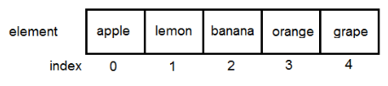

Its actual use we will see at time of selenium. example in eclipse.